**Emir Yigit Akpinar 28139**

**CS 405 Assignment 1 Report**

This computer graphics assignment aims to visualize a statistic graph with using SVG elements. A dataset was chosen from the TUIK website to use as a statistic resource. “Deaths by month and sex 2009-2022” was used as a dataset. However, only deaths in 2022 were used to visualize an SVG graph. The used data is indicated in a red box in **Figure 1**.

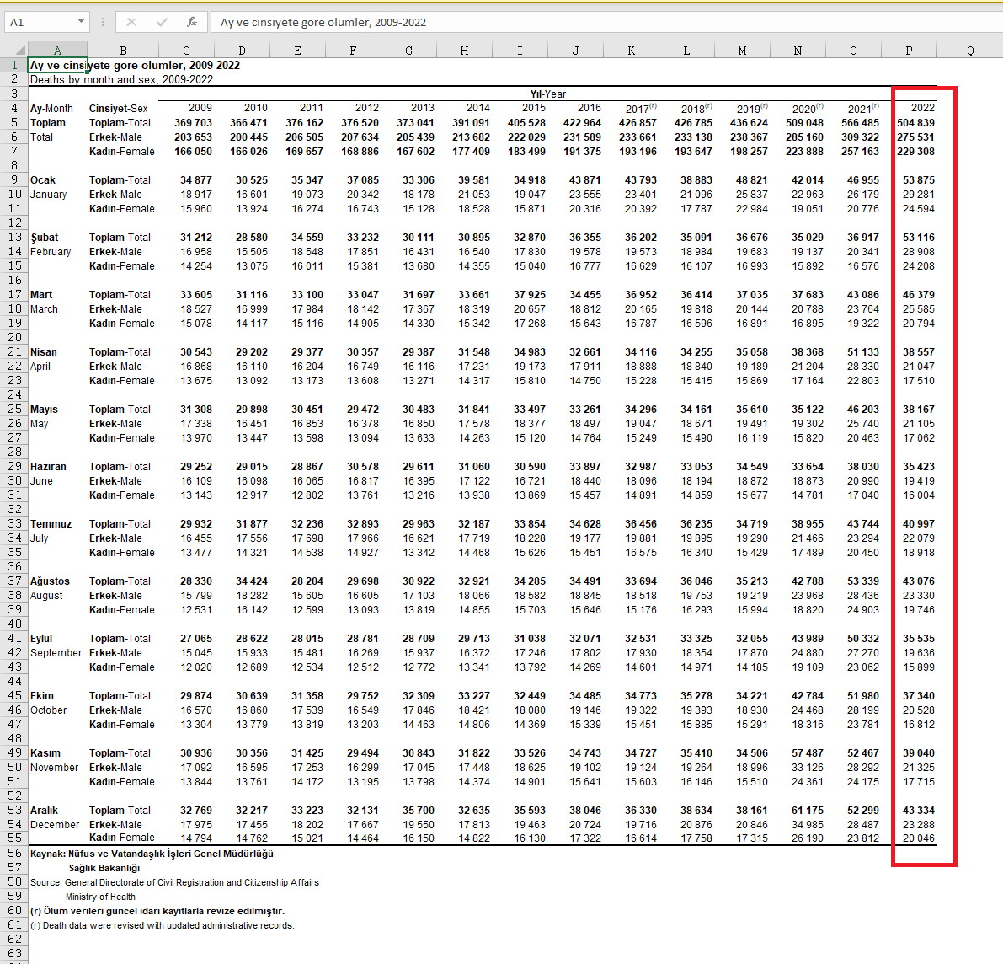

**Figure 1**

To visualize an SVG graph a HTML file was created. Then a view box with 1280 x 720 (720p HD resolution with 16:9 aspect ratio) pixels was added. However, the graph has only 1200 pixels width and 600 pixels height inside the view box. Because of that, two perpendicular lines were drawn into view box to visualize the x and y axis of the graph. The x axis starts from the (80,640) point and ends at the (1280, 640) point. The y axis starts from the (80, 40) point and ends at the (80, 640) point. For better understanding see **Figure 2**.

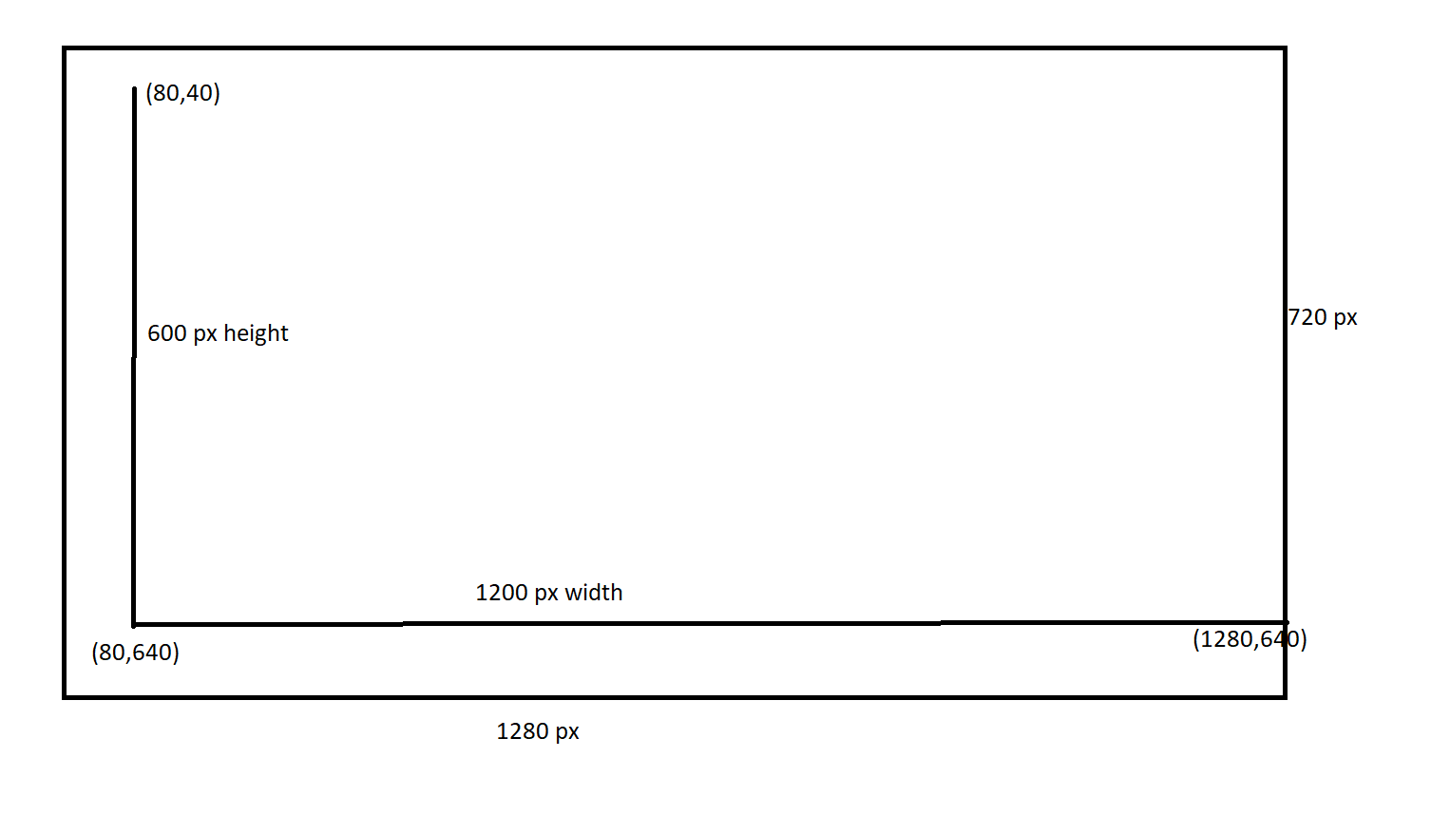

**Figure 2**

The important data from the dataset has been stored in a javascript array. There are 3 arrays from the dataset. These are the total deaths, male deaths and female deaths for each month in 2022. There are 12 months (January to December) in the graph therefore at each 100 pixels on x axis represents a month and in each month there are 3 rectangles to symbolize male (blue), female (red) and total (black) deaths. Each rectangle has 20 pixel width and their heights have been determined by the data. For y axis we have 600 pixel height and each pixel represents 100 deaths. Therefore maximum of 60000 deaths can be represented by the graph. The data from the dataset is divided by 100 and given into rectangles as their heights. Thus heights of the rectangles depend on the death count from the data.

A javascript code was used to automate to draw process in the HTML file. A for loop iterates 12 times to draw 3 rectangles; write month names from January to December in each iteration. Also, y axis has been divided into 7 segments with 7 iterations and each segment indicates the 10000 deaths from 0 to 60000 (60000 included). However, the legends for the graph were coded manually (not by script) at the beginning of the HTML code. There are 3 elements in the legend: total deaths which are represented by black, male deaths which are represented by blue and female deaths are represented by red. To draw rectangle and and lines basic svg functions from [www.w3.org](http://www.w3.org) have been used.